VISIL LabS
For Innovations

INNOVATIVE 3D PRINTING SOLUTIONS
At Visil Labs, we take pride in being at the forefront of 3D printing technology.

Our commitment to excellence, cutting-edge innovation, and seamless integration of advanced printing solutions make us the undisputed leaders in delivering the ultimate 3D printing experience.

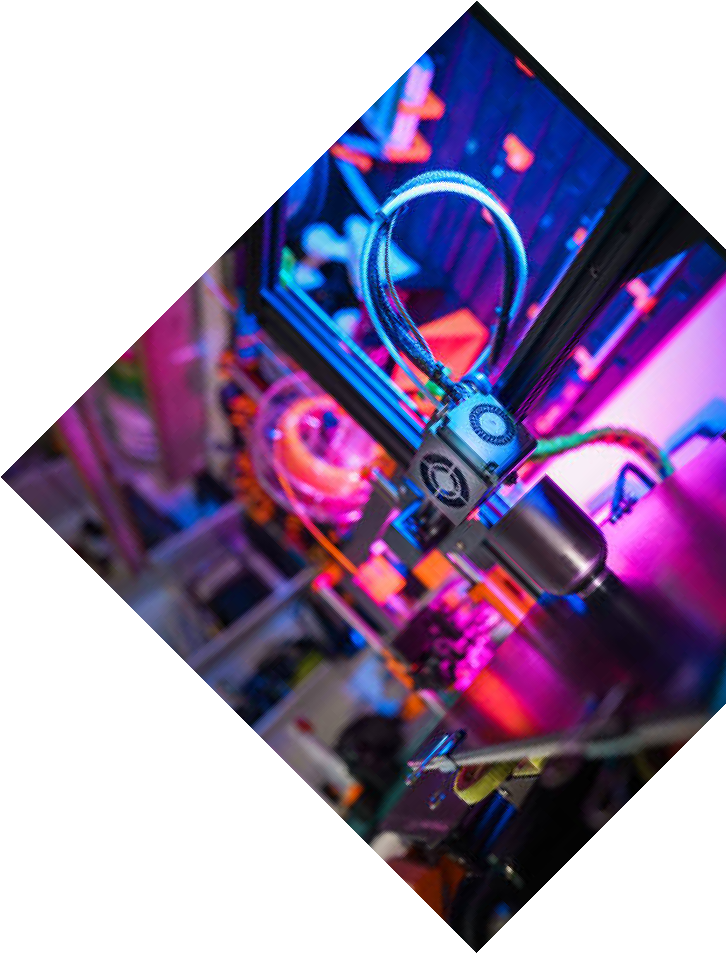
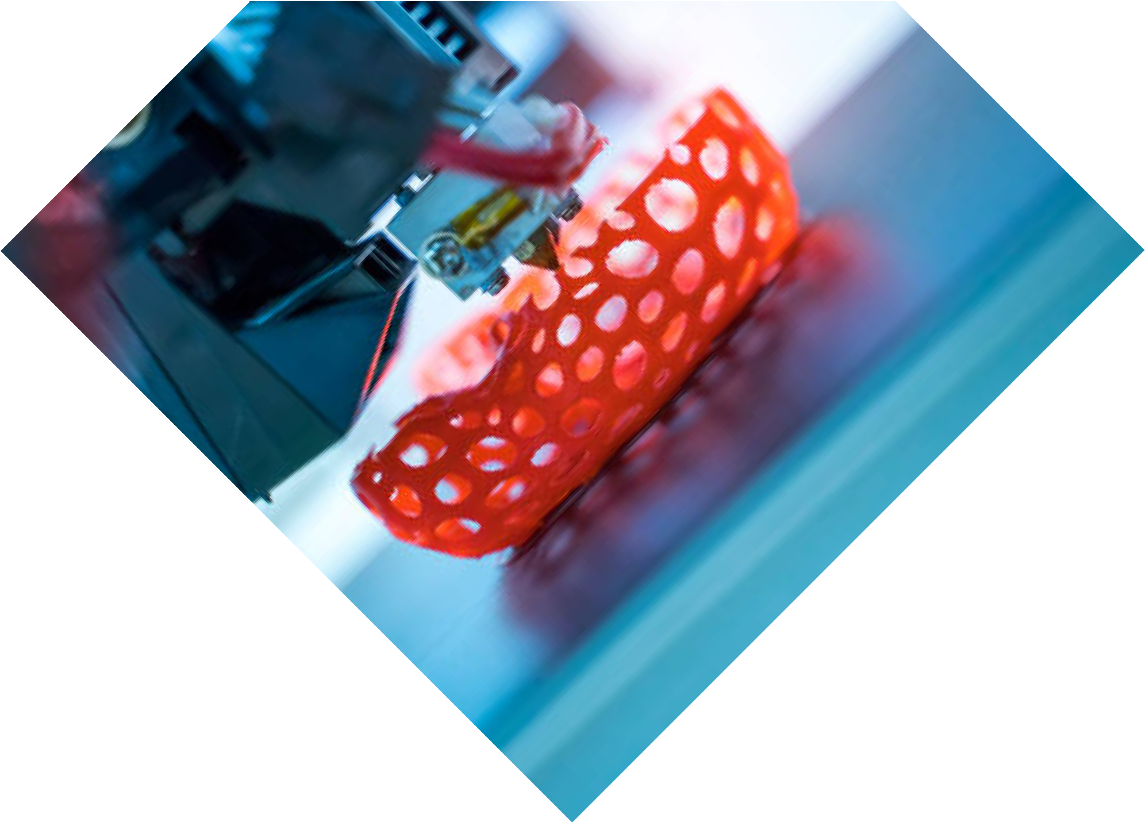

Experience the pinnacle of manufacturing with us, where every detail is precisely crafted and effortlessly produced, setting new standards for quality, efficiency, and creativity.

Call For Booking :

www.visiltech.com

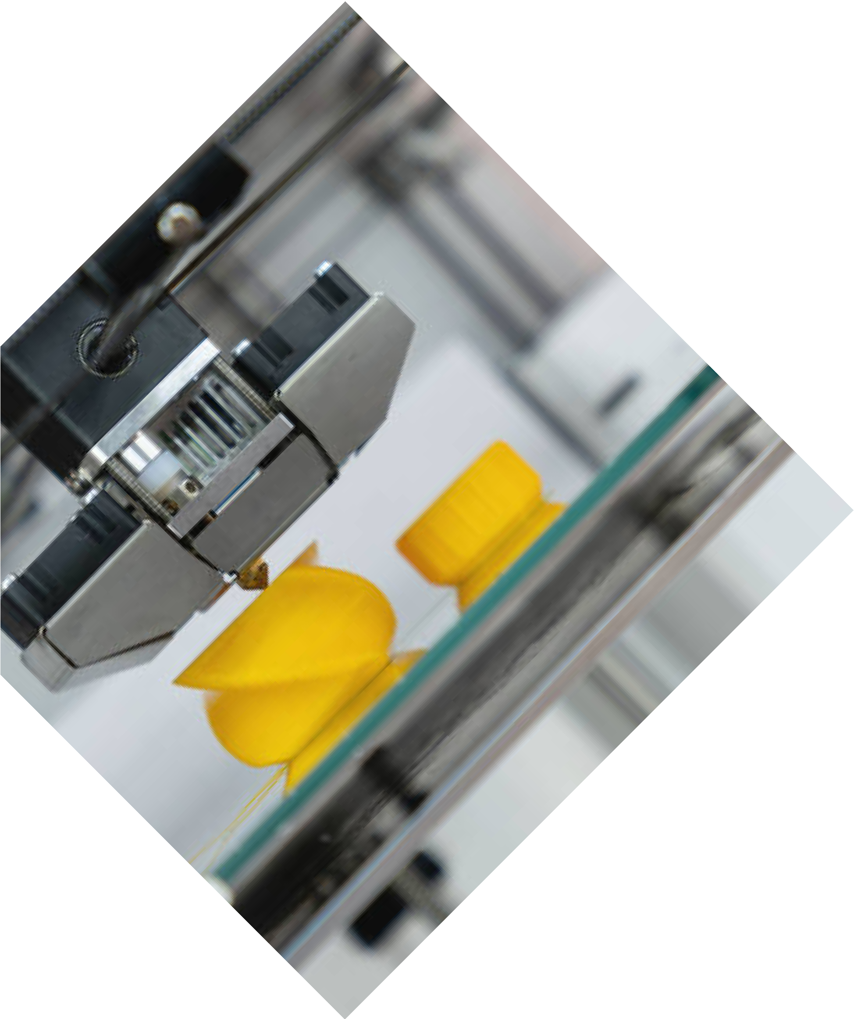
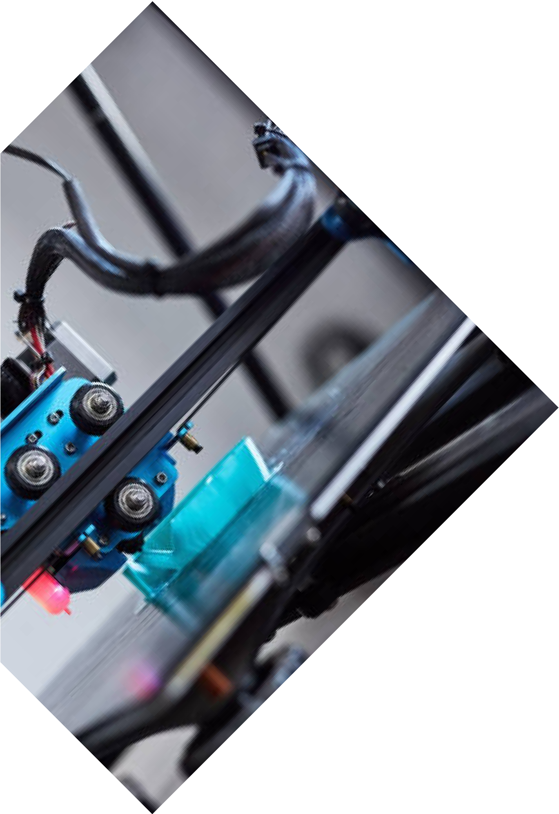
ABOUT US

www.visiltech.com
Visil Labs is a high-end solution provider for 3D printing and related solutions for clients.

We are backed by cutting-edge technology and a talented team working persistently to transform your thinking into reality with precision as never
experienced before.

An entrepreneur, engineer, educator, or artist, let our 3D printing services empower you by bringing concepts to life.

Call For Booking :

OUR SERVICES
PROTOTYPING

Bring your products to life faster than ever by utilizing our rapid prototyping service.

We will be of help in the visualization, testing, and refinement of ideas quickly and affordably.

With our 3D printing technology, you can come up with an exact working prototype for it to be tested with any design flaws so you could work on the necessary changes before getting it into full production.

Call For Booking :
www.visiltech.com

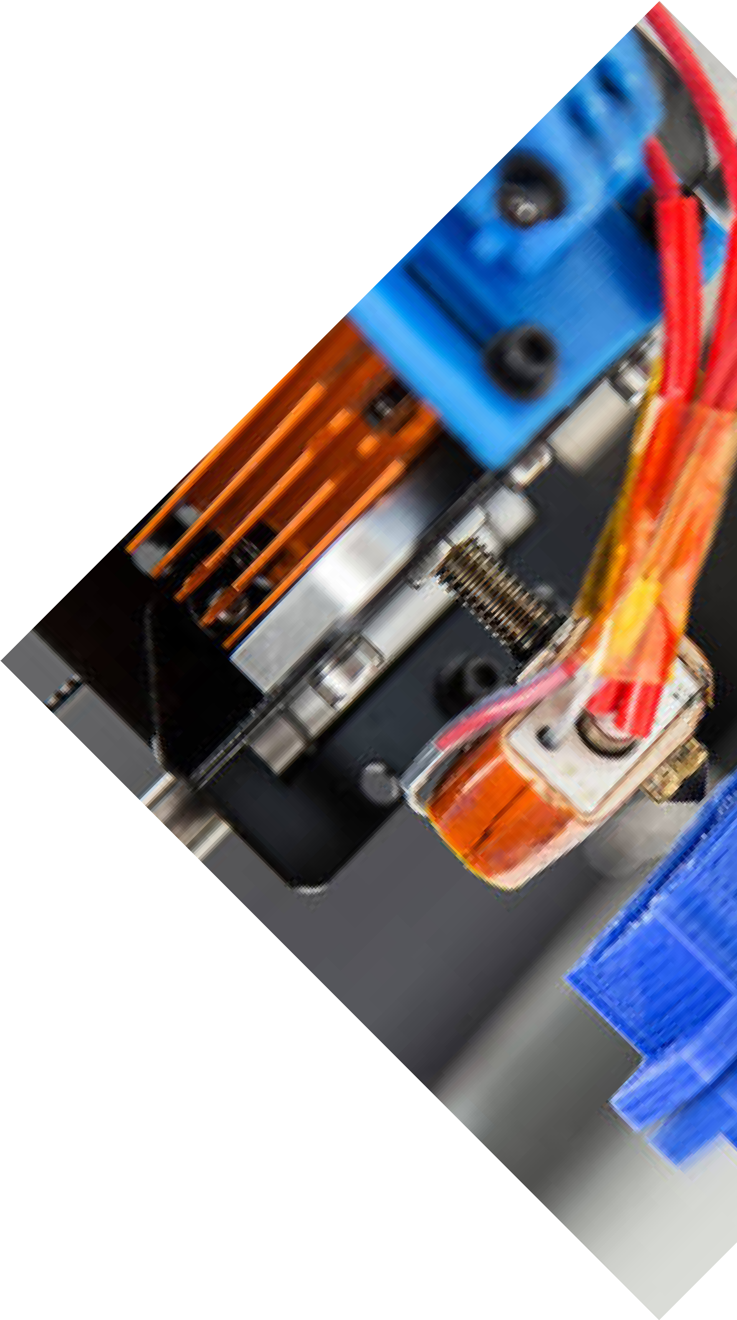
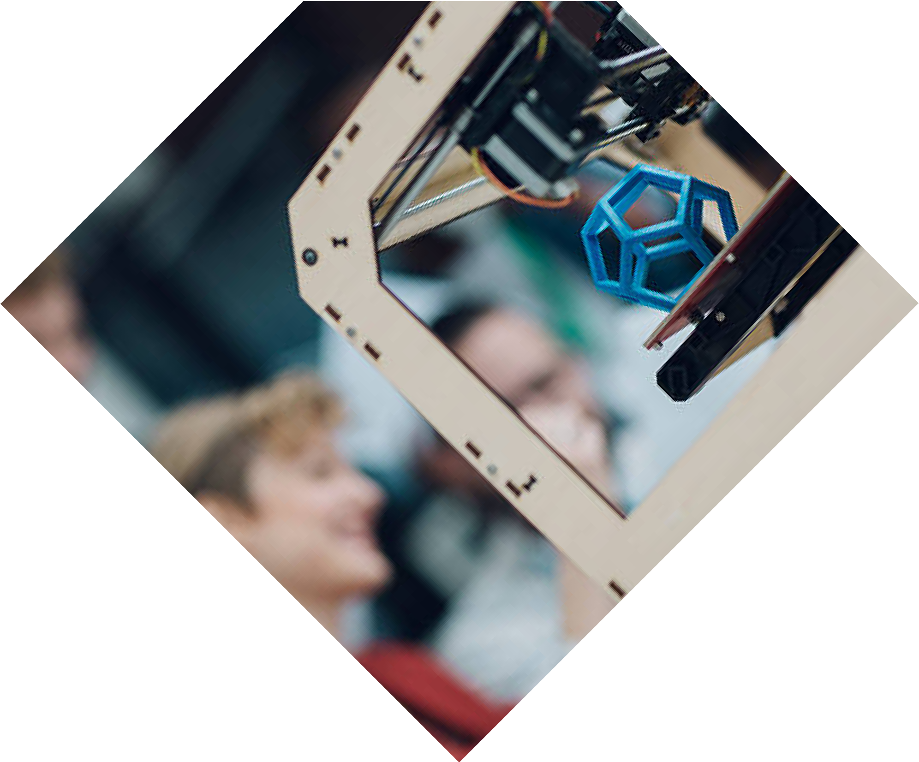

CUSTOMIZED MANUFACTURING

Our 3D printing technology helps in the production of customized parts, from small batches to the largest possible numbers of units, with a high quality and
consistency.

We are known for our service to a huge array of industries in terms of individual, made- to-suit solutions while adhering to strict specifications and standards.

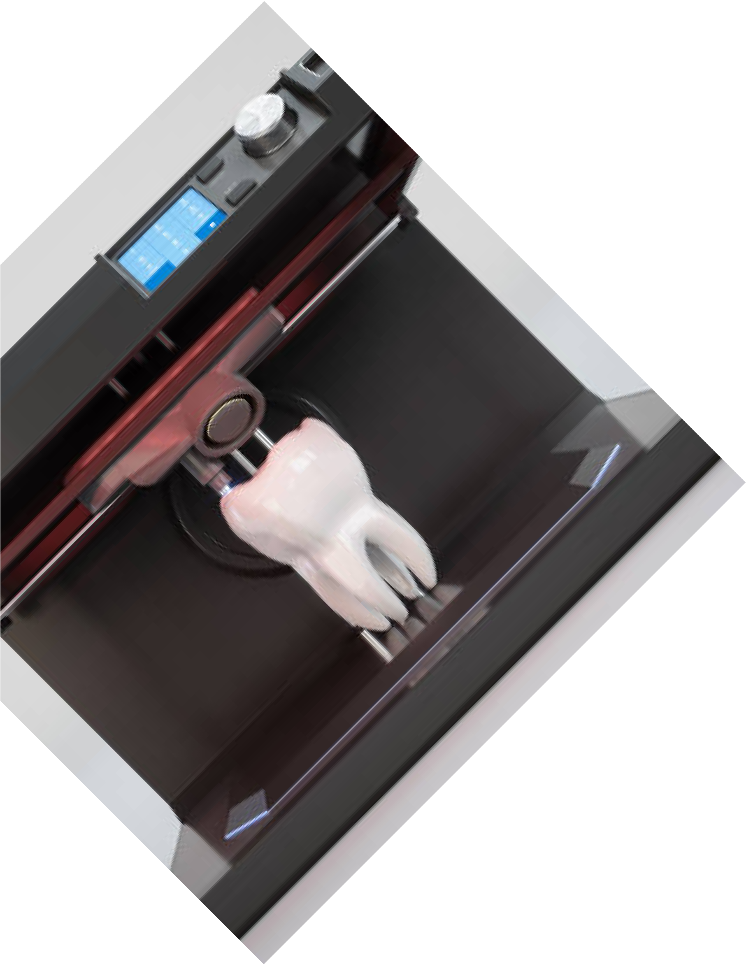
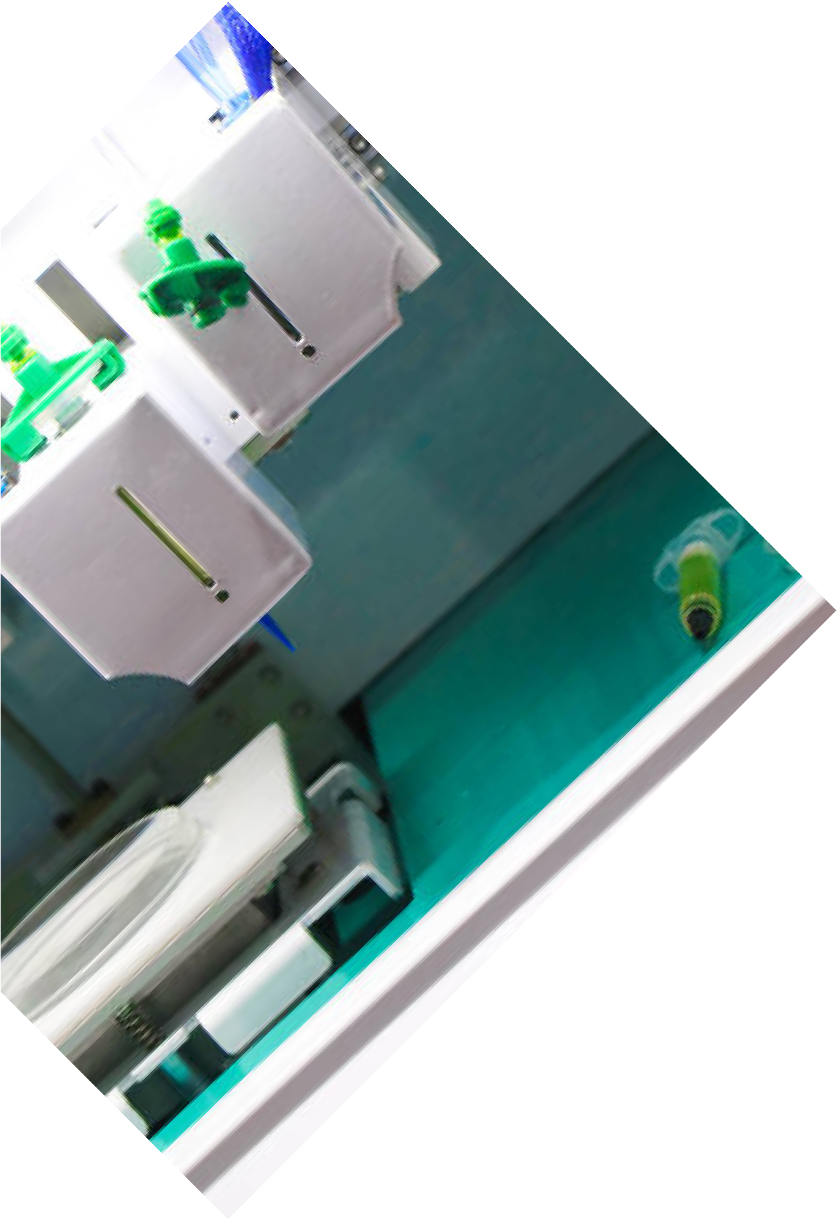
Call For Booking :

www.visiltech.com

DESIGN AND ENGINEERING SUPPORT

Regular consultation by our seasoned engineers and designers working in tandem to ensure that your designs are optimized for 3D printing, guaranteeing the best results for your projects.

State-of-the-art advice and recommendations on material selection, structural integrity, cost efficiency, achieving optimum performance, and aesthetic values for attaining overall perfection.

Call For Booking :
www.visiltech.com

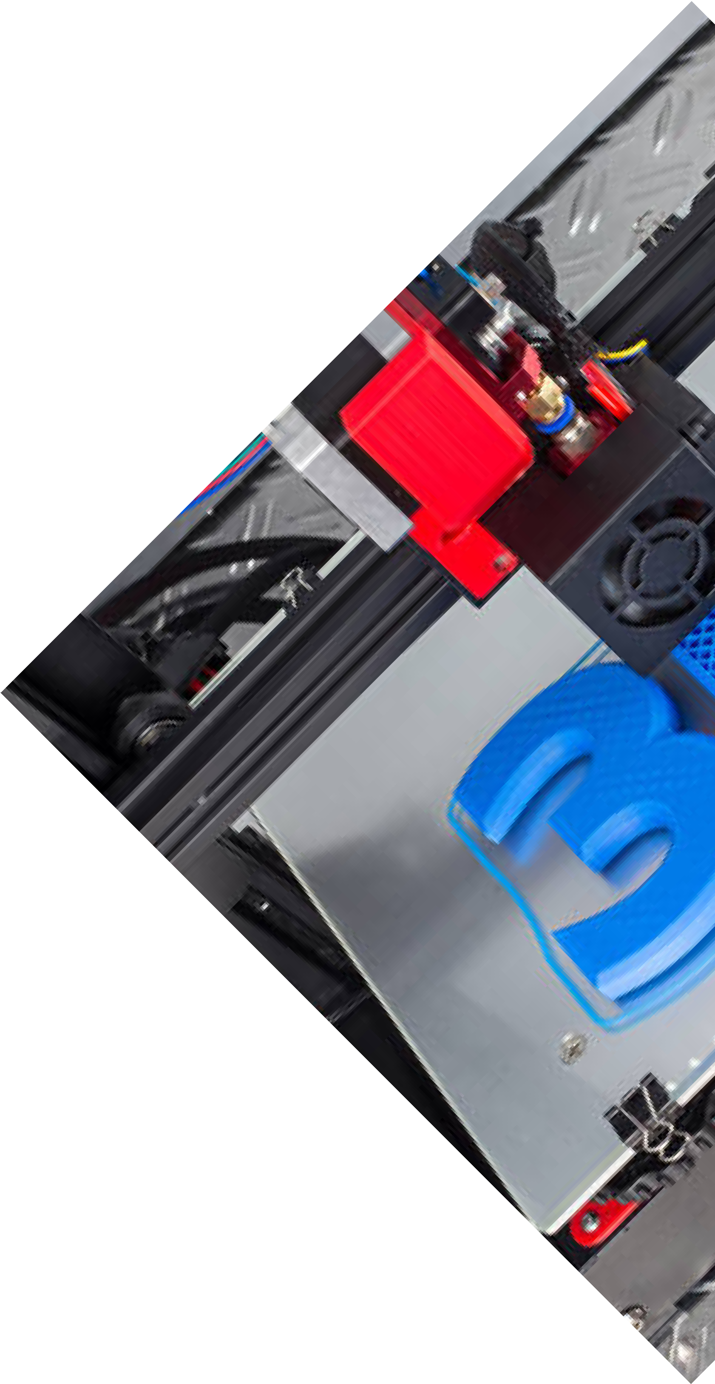
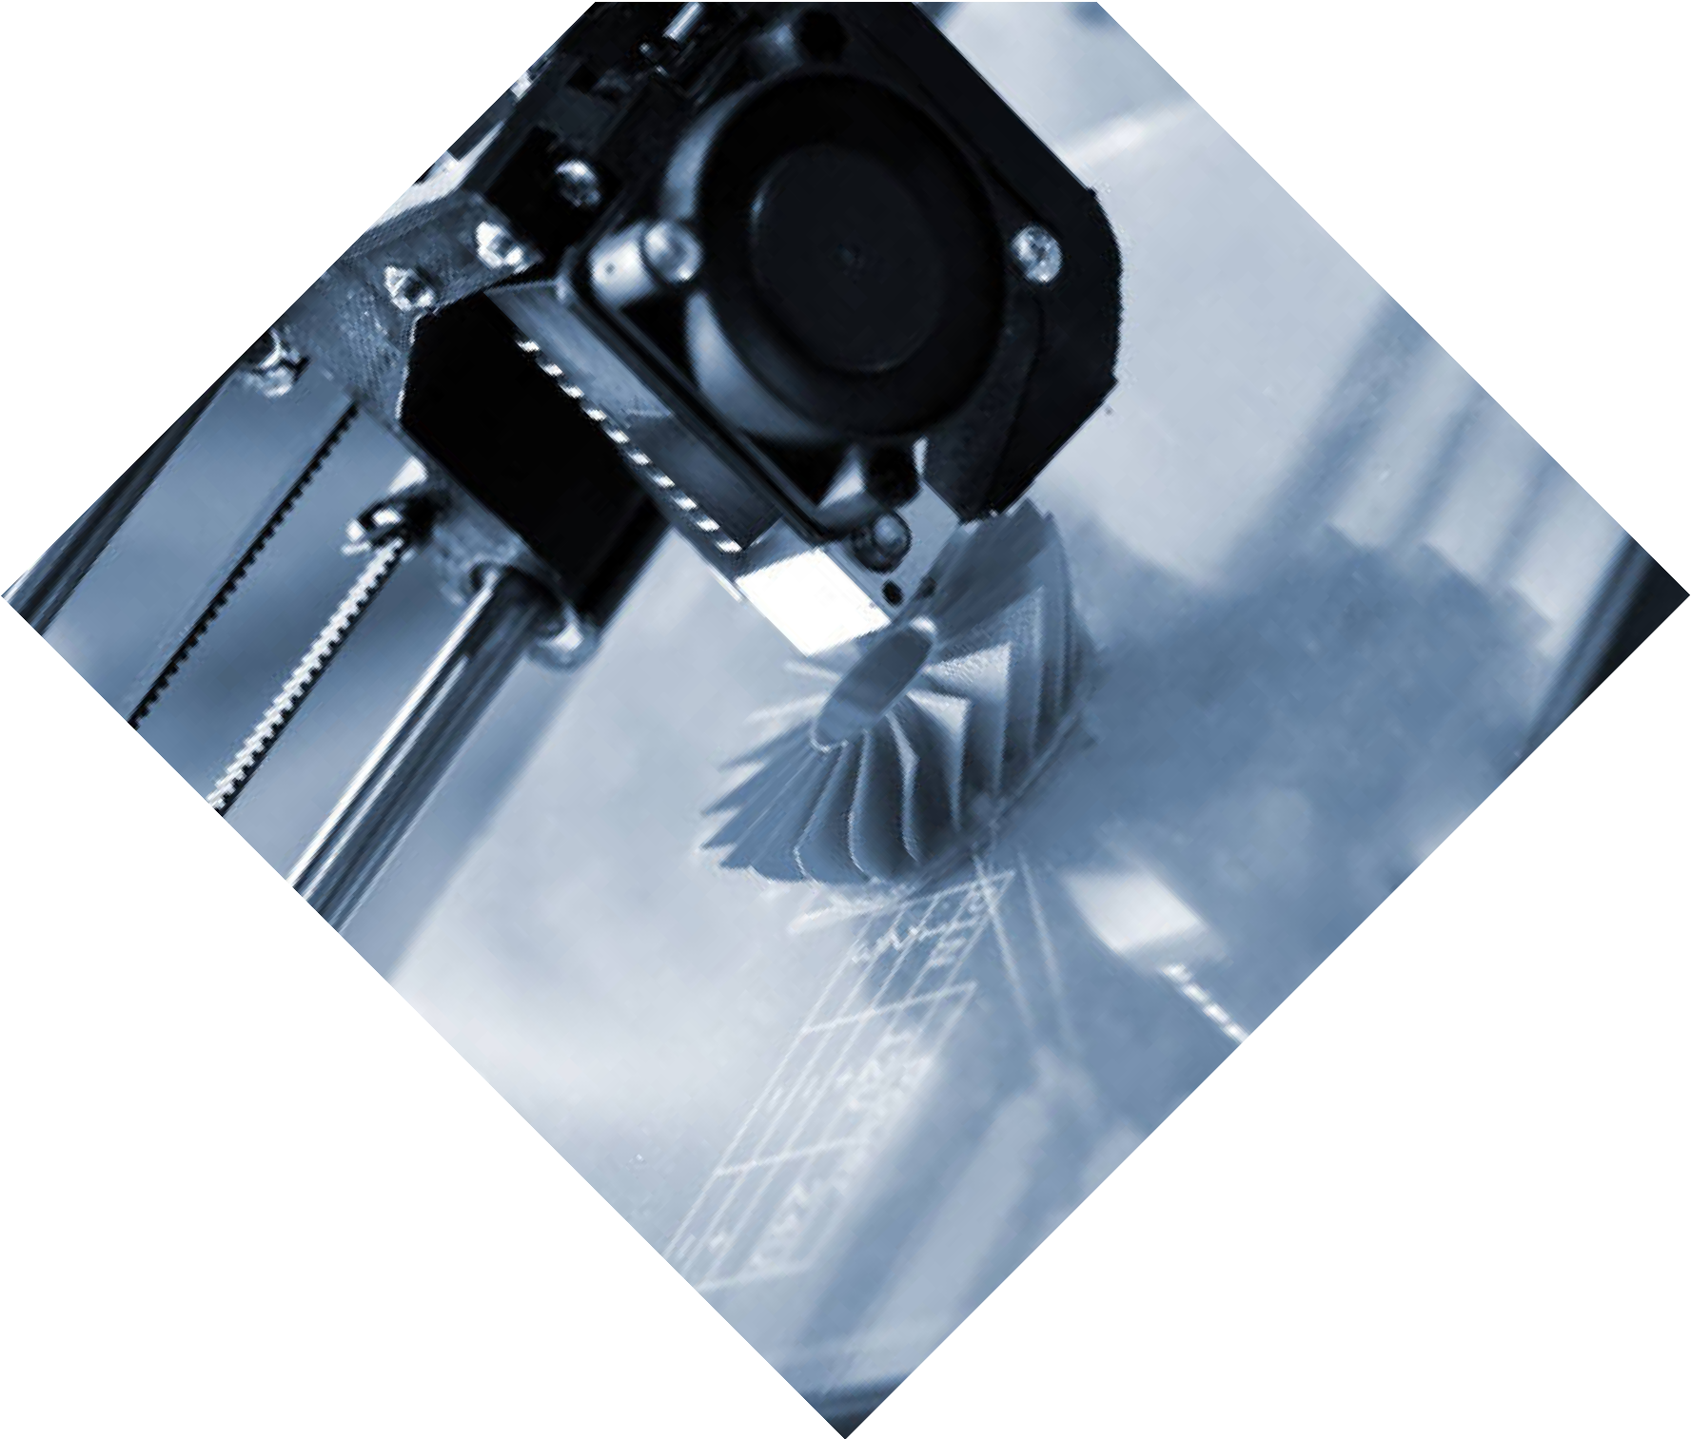

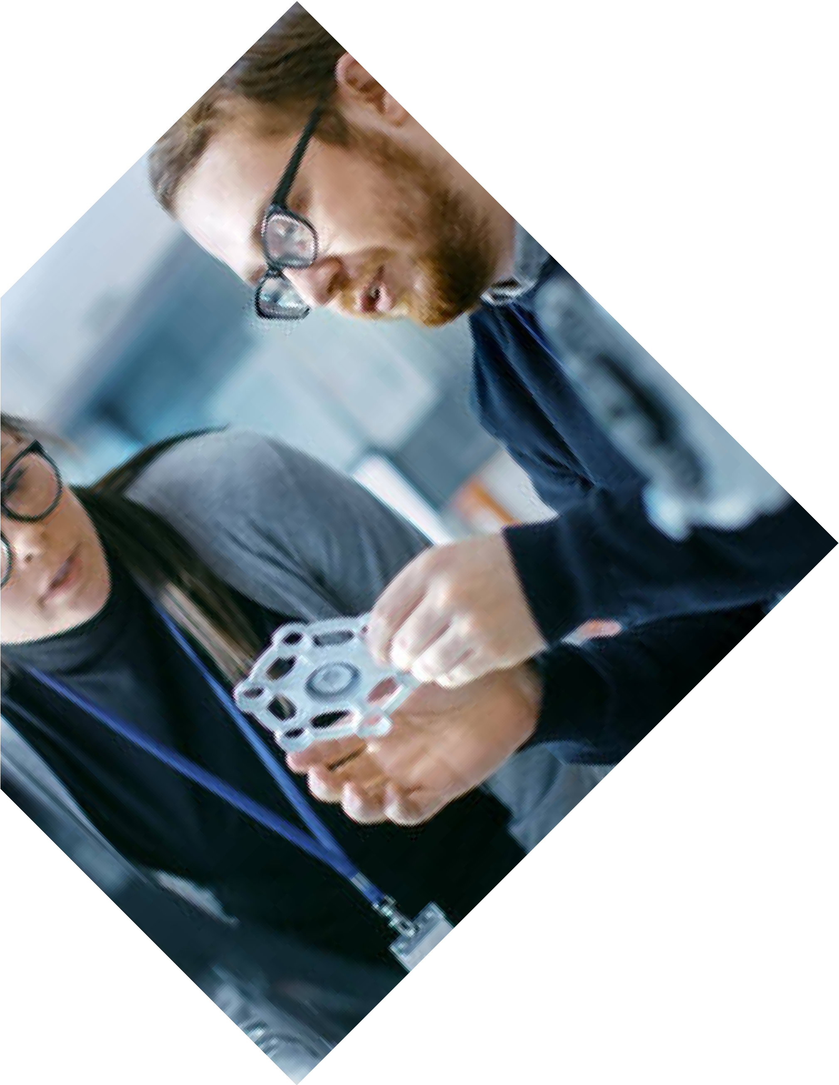
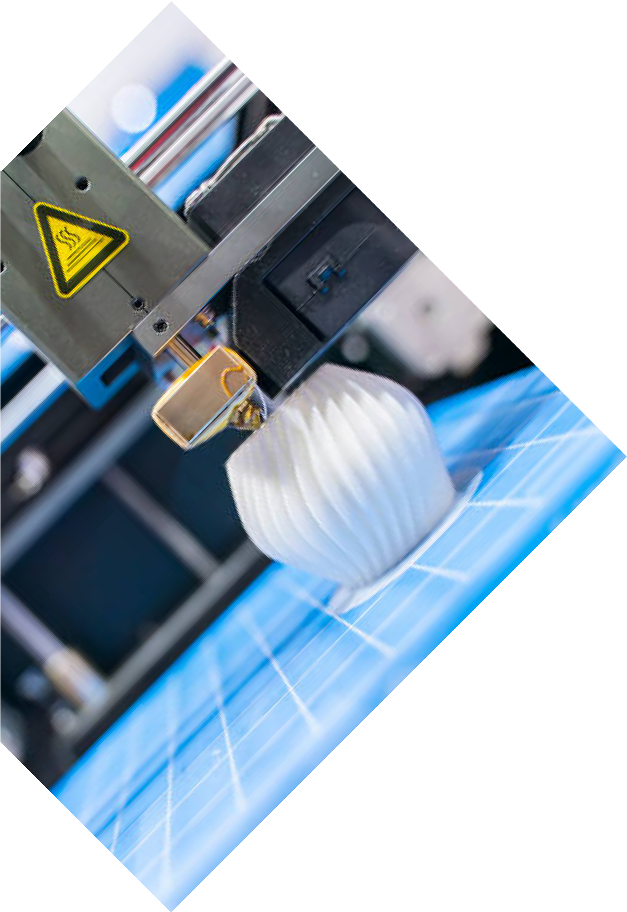
models.
www.visiltech.com

MATERIAL SELECTION

From PLA, ABS, and PETG to nylon and many other materials, you will have precisely what you will need for your application.

Such a diverse materials portfolio allows us to service our clients' needs with either high- strength engineering parts or detailed artistic

Call For Booking :

INDUSTRIES WE SERVE
AEROSPACE
High-Performance, Lightweight, and Durable Parts
Our 3D printing solutions support the creation of intricate aerospace parts that reduce weight but retain strength and reliability.

HEALTHCARE
Custom prosthetics, medical models, and surgical instruments.
We provide precise and patient-specific medical solutions raising the standard of quality in care and outcome.
Call For Booking :

www.visiltech.com

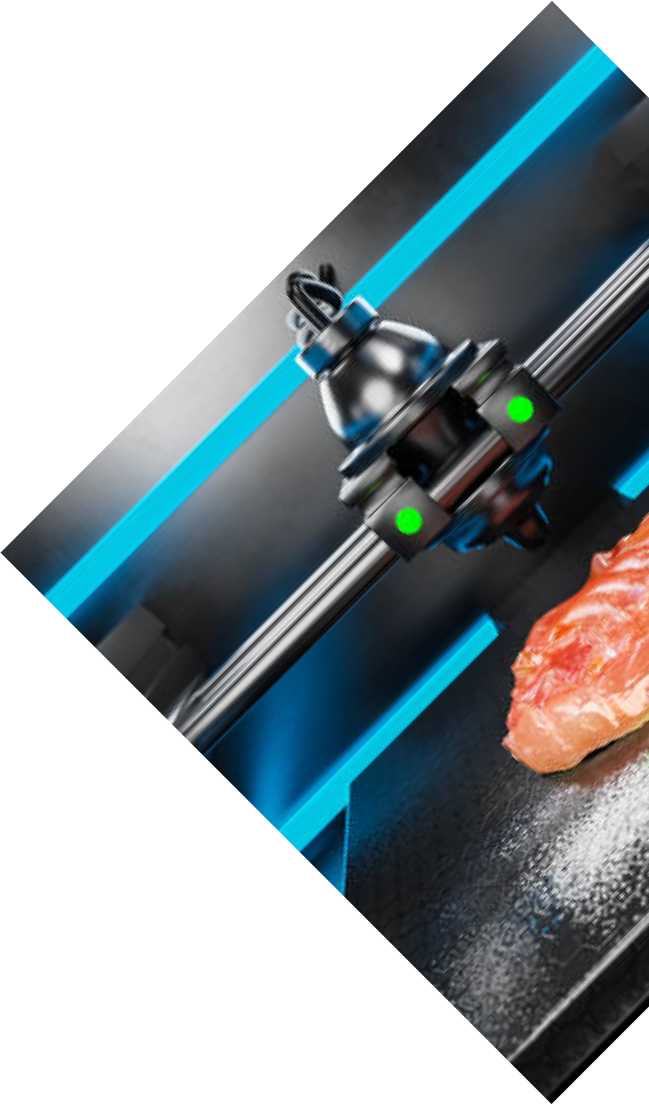
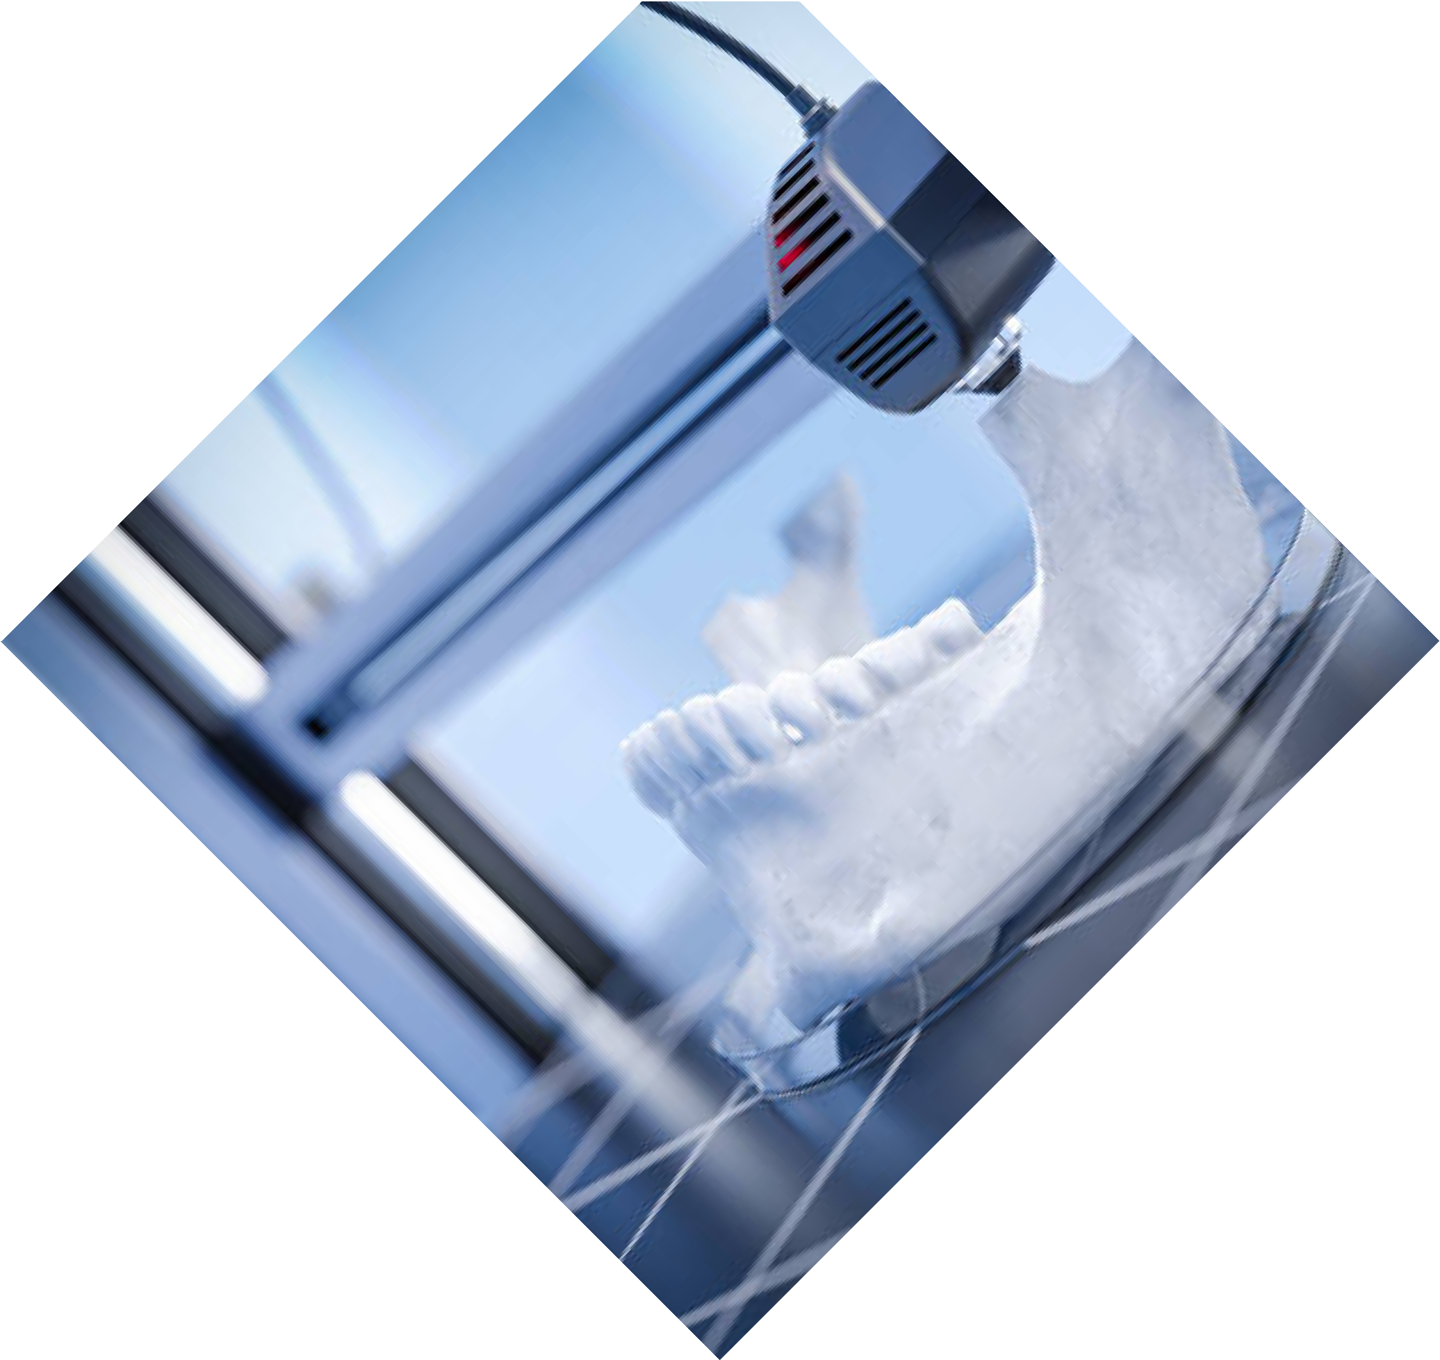

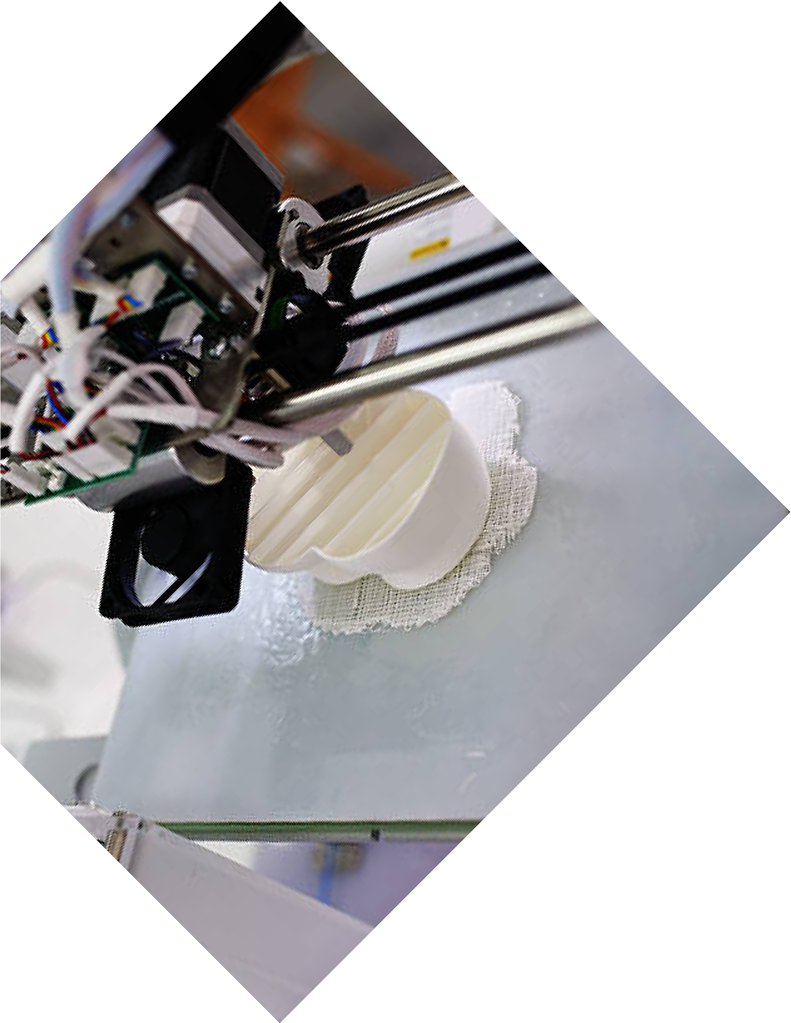
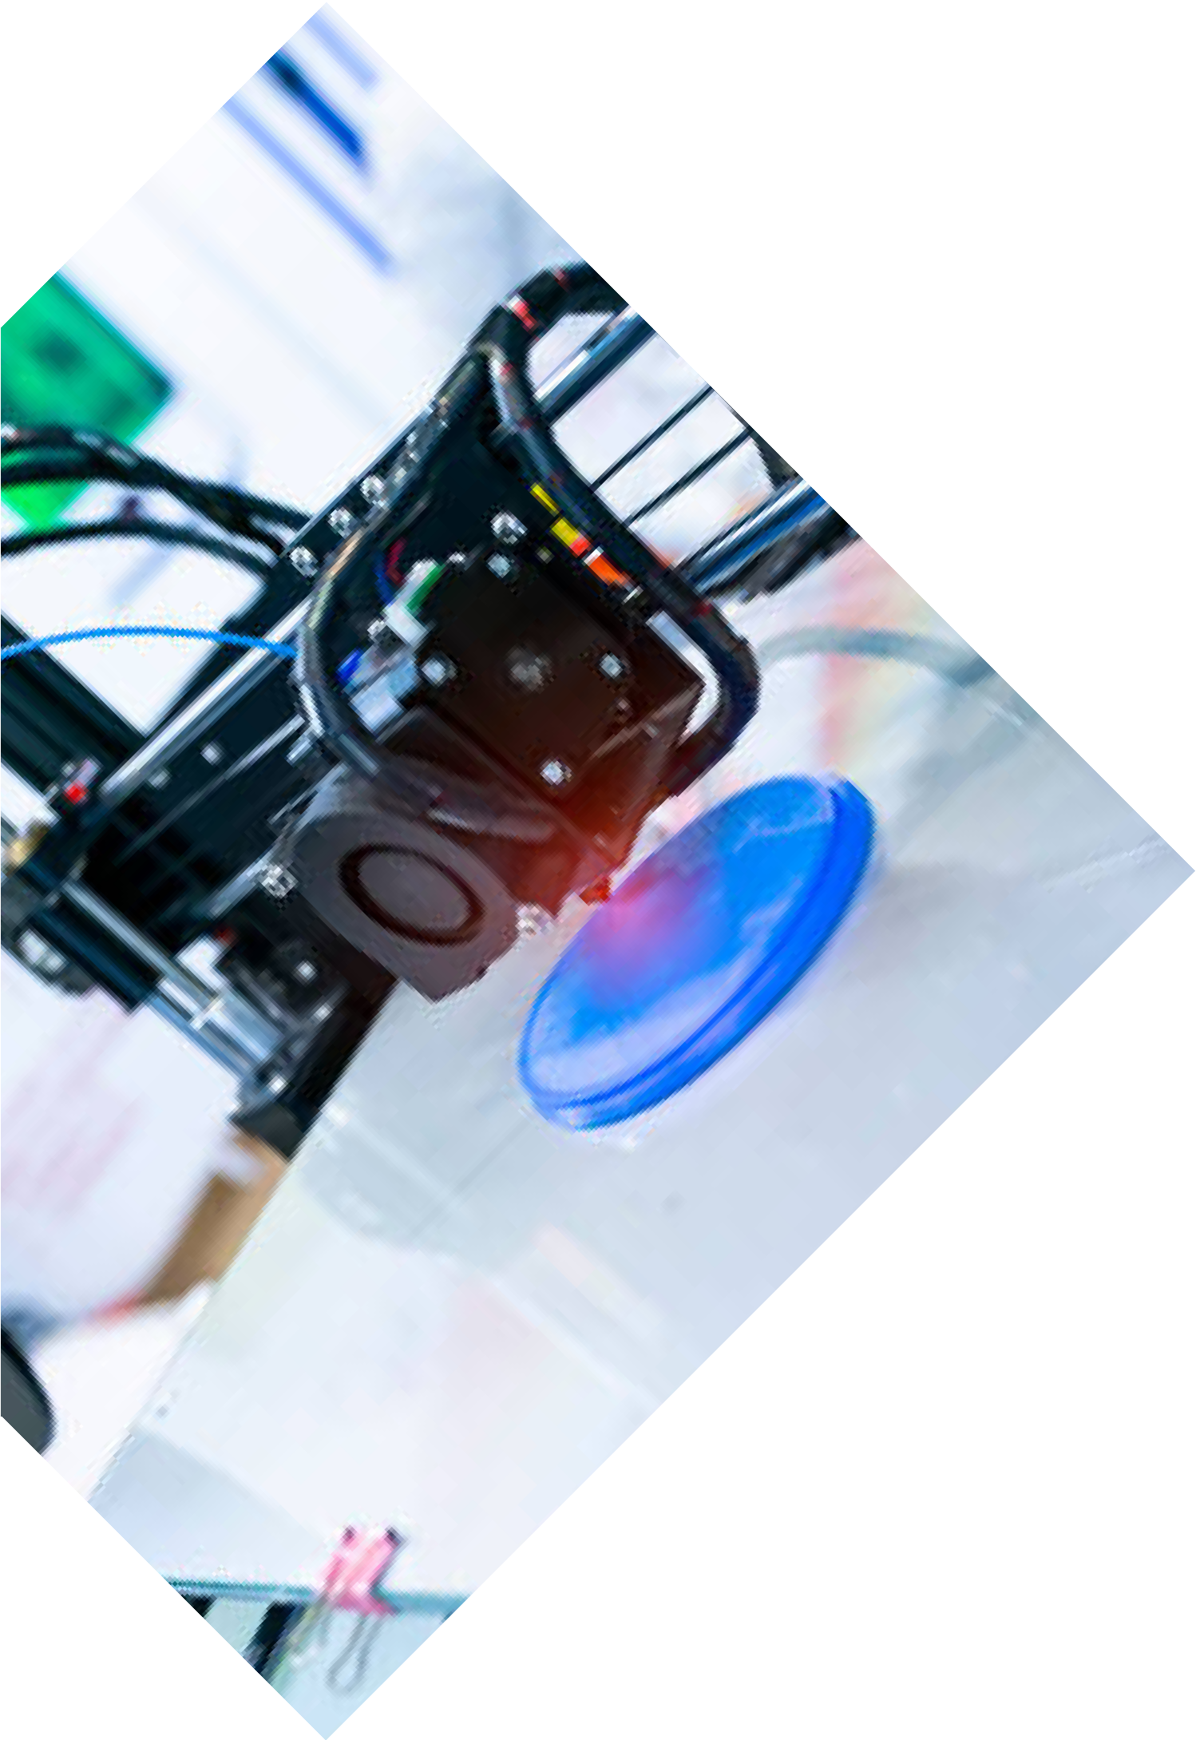
growing demand for
personalization.
www.visiltech.com

AUTOMOTIVE
Functional prototypes, custom parts, and tooling solutions.
Car parts can be prototyped and tested with breakneck speed using our 3D printing technology,
offering a platform for accelerated innovation in the
automotive sector.

CONSUMER GOODS
Innovative product designs, and
personalized items. We help business enterprises produce special consumer products and those that can be tailored to unique individual requirements, thus meeting

Call For Booking :

WHY CHOOSE VISIL TECH?
DOMAIN EXPERTISE
With experience in the industry, we are known for our commendable services in 3D printing and design.
We maintain the quality and service standard by consistently updating ourselves with new technologies to deliver the best possible solution to our clients.

STATE-OF-THE-ART TECHNOLOGY
We have applied the latest 3D printing technology in production to produce accurate results that are reliable.
We have invested in the best equipment to ensure the highest standards of accuracy and detail.

Call For Booking :
www.visiltech.com

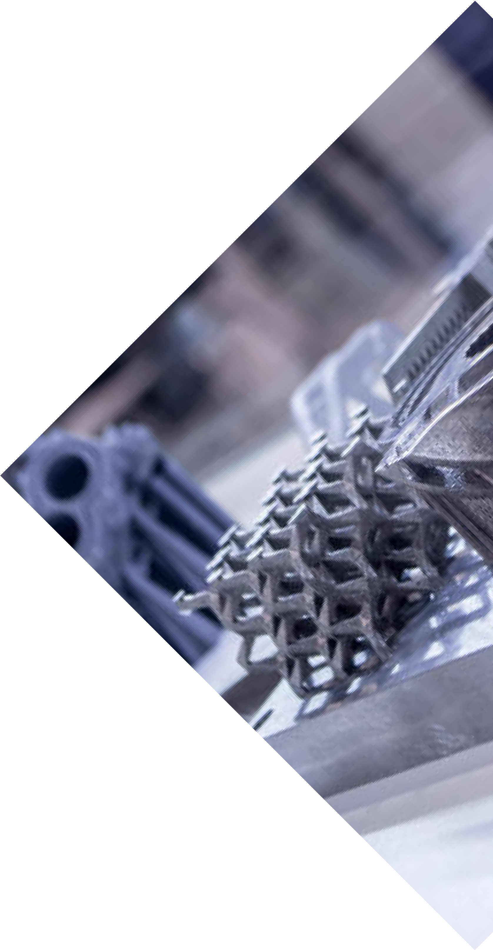
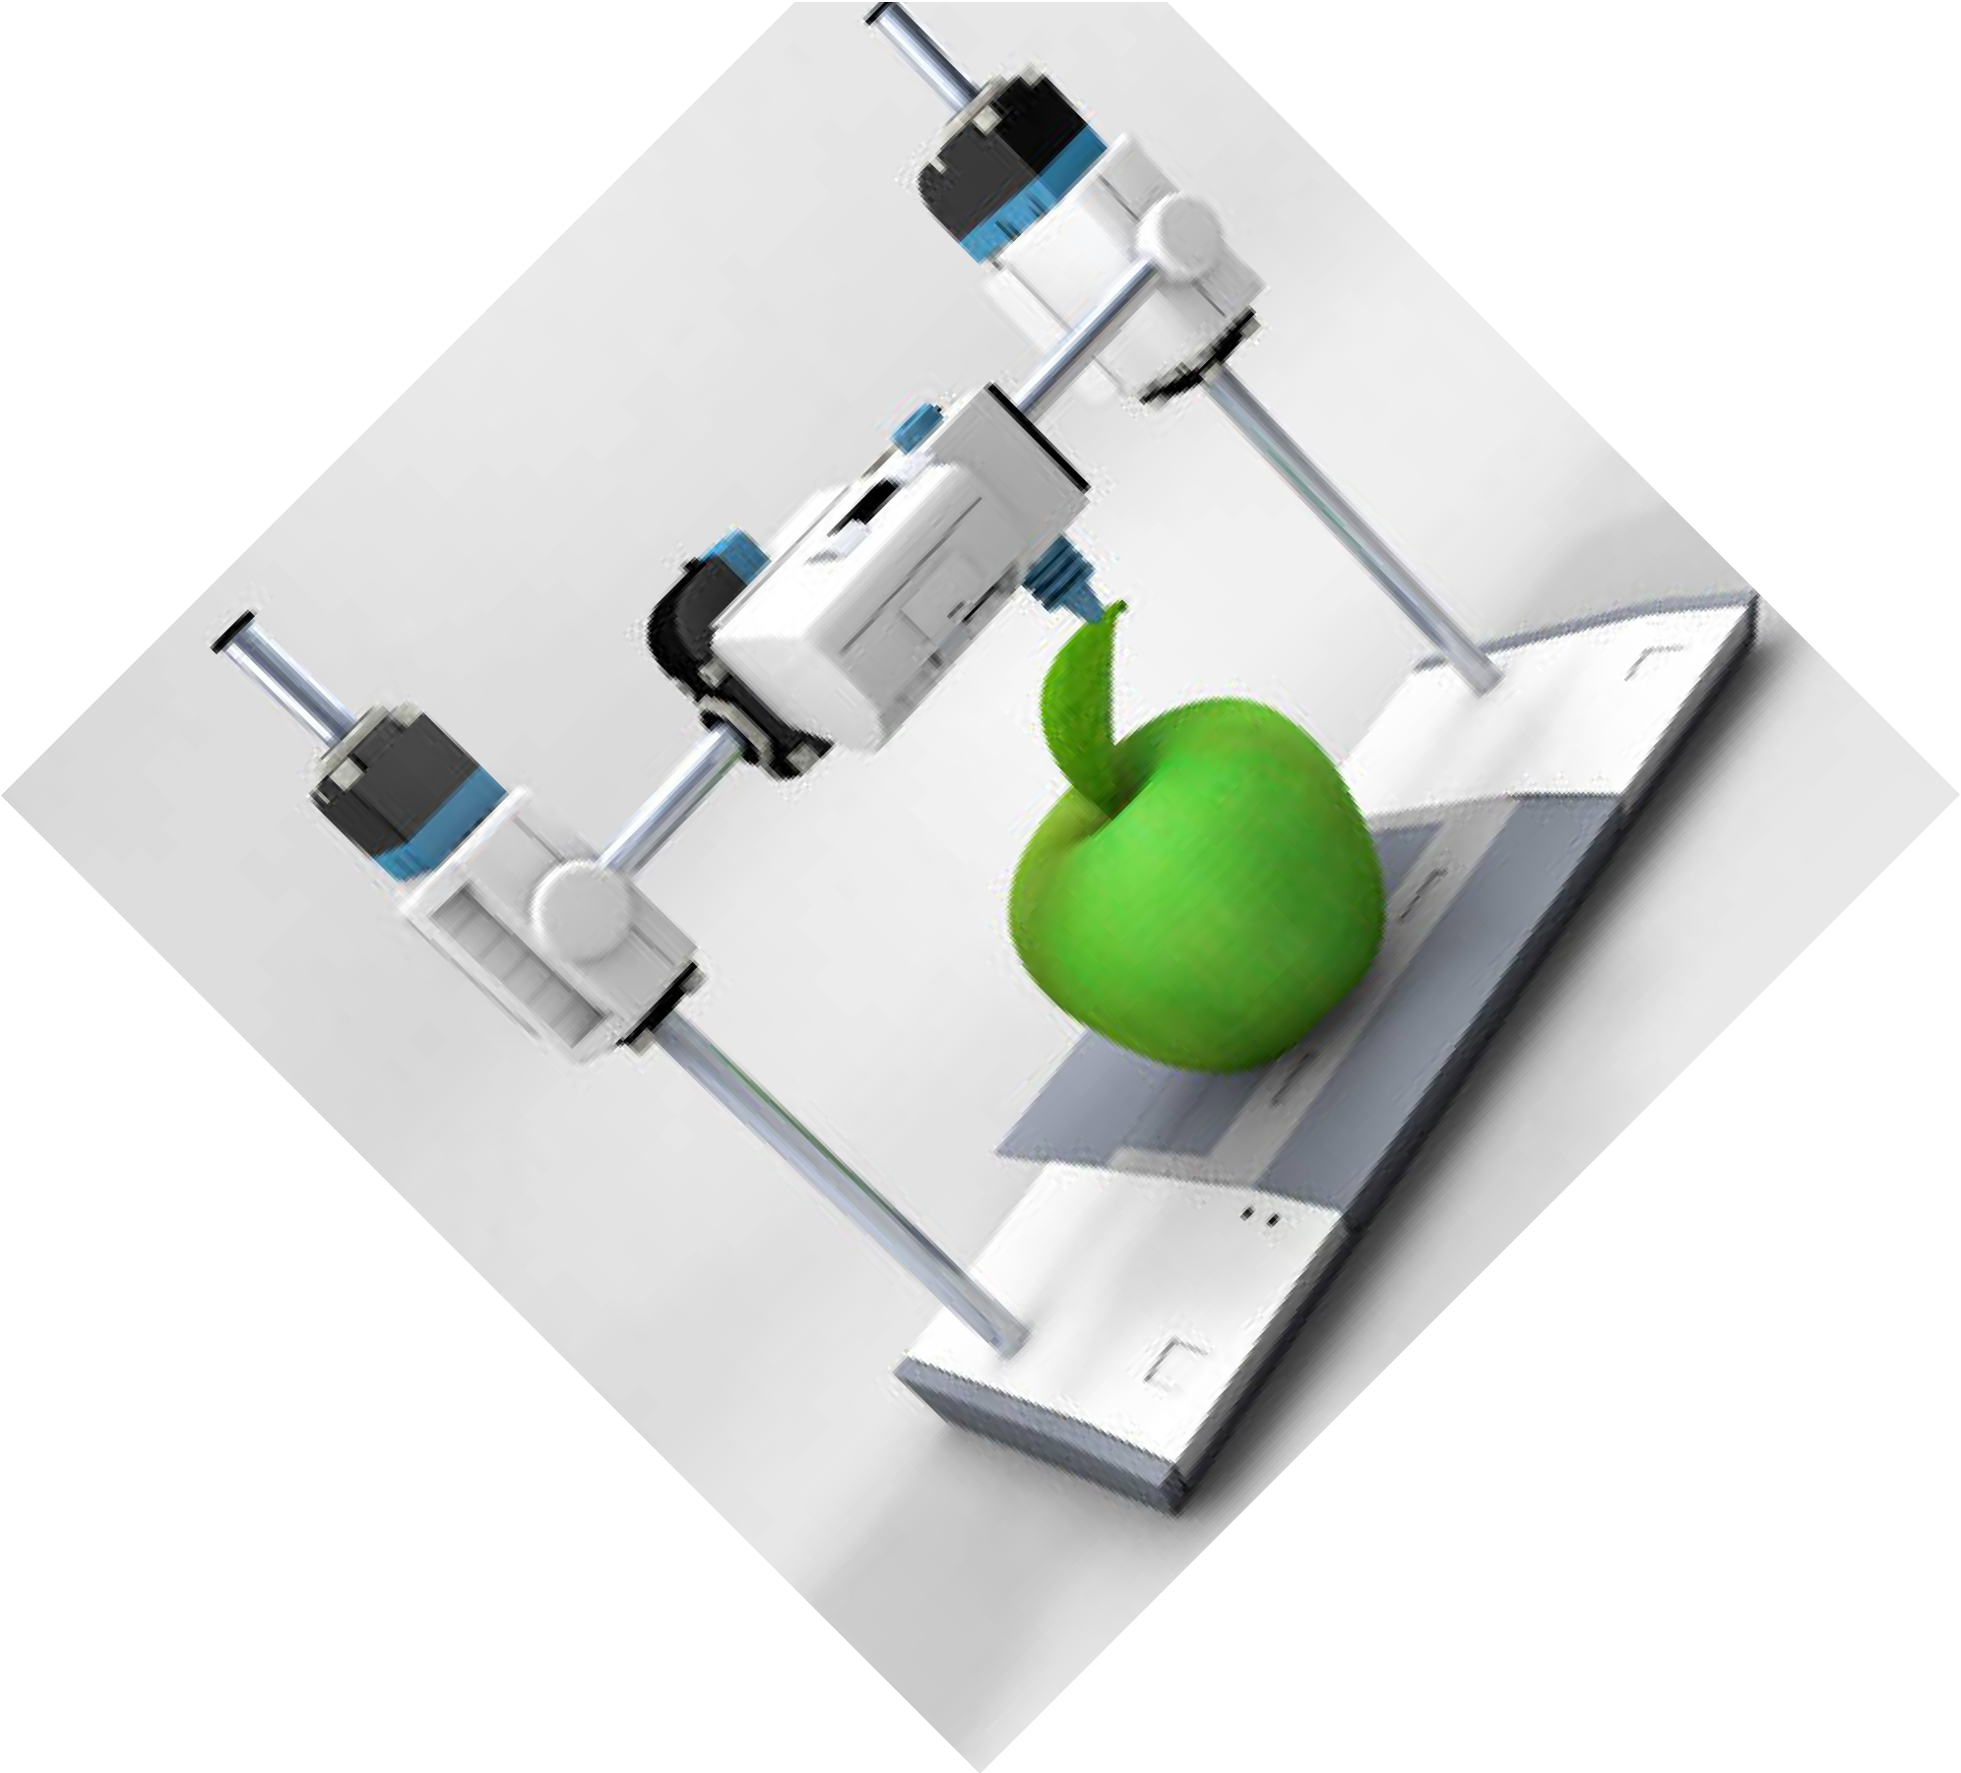

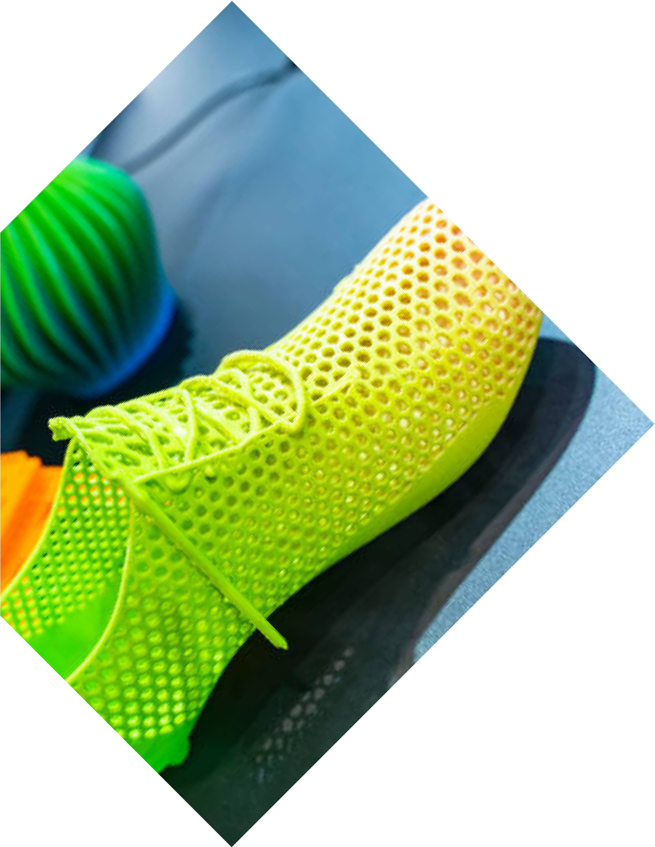
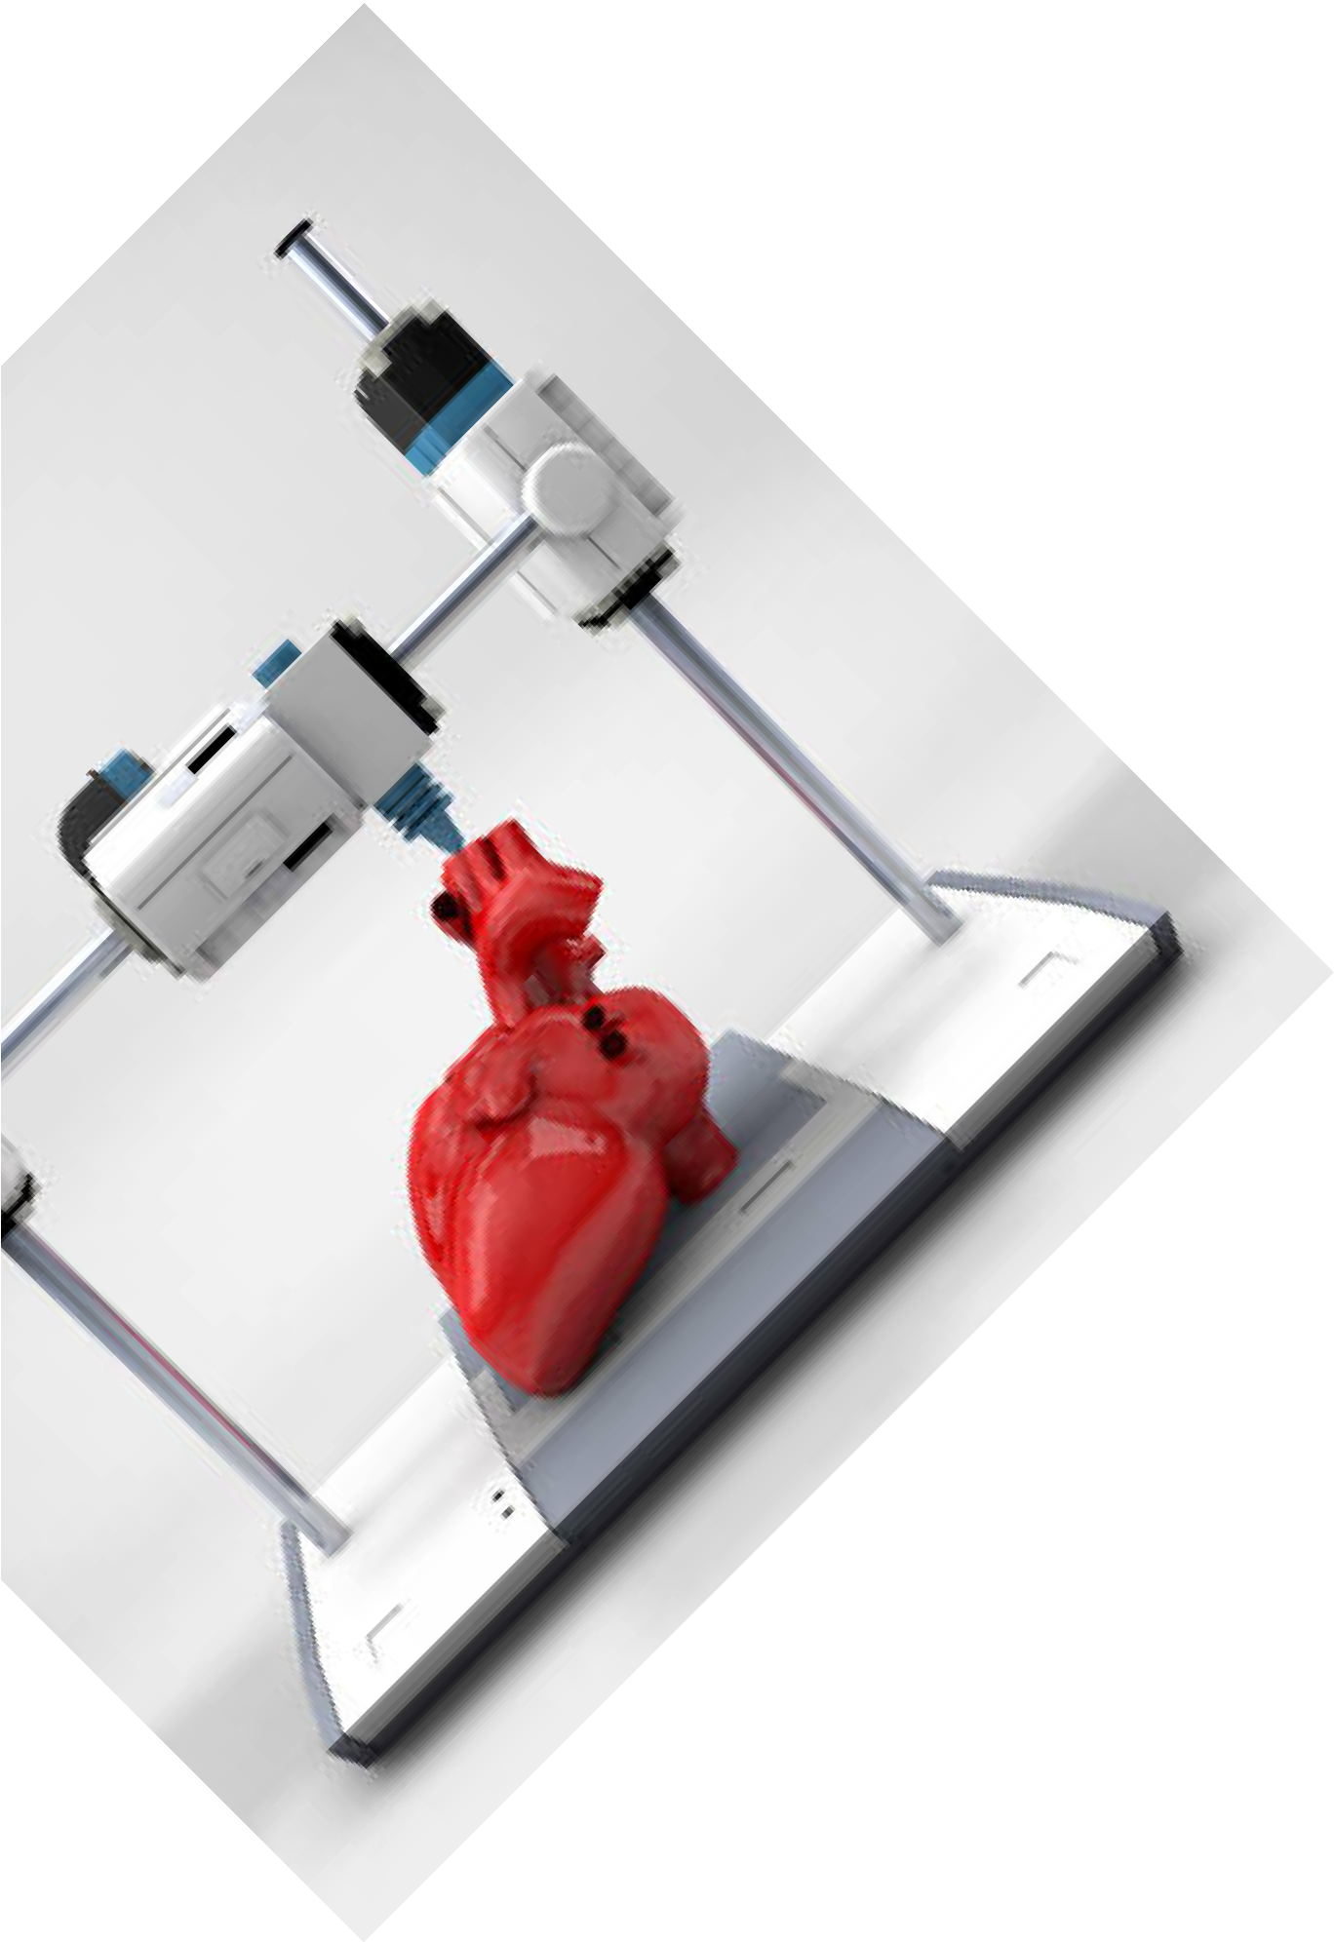
money.
www.visiltech.com

FAST TURNAROUND
We understand that it's not just about quick delivery but also meeting the deadlines. With our efficient processes, we ensure fast delivery of
orders without compromising on the quality.

COMPETITIVE PRICING
Our 3D printing services will be cost-effective in ways that do not harm performance.
We have transparent pricing policies that will let you get the best value for your

Call For Booking :

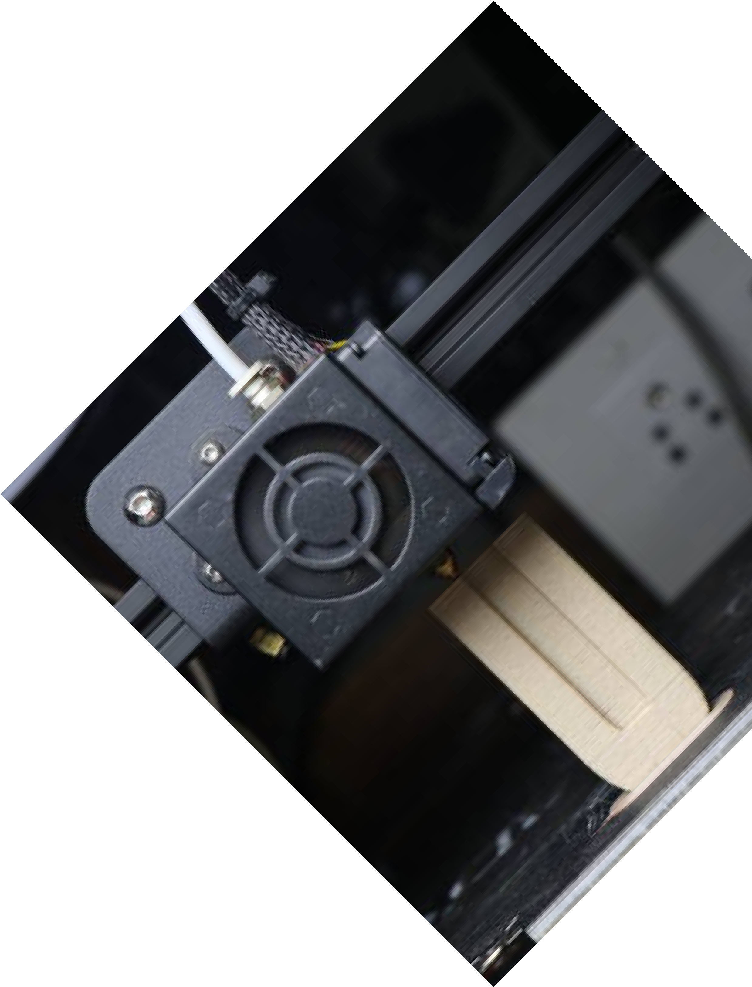
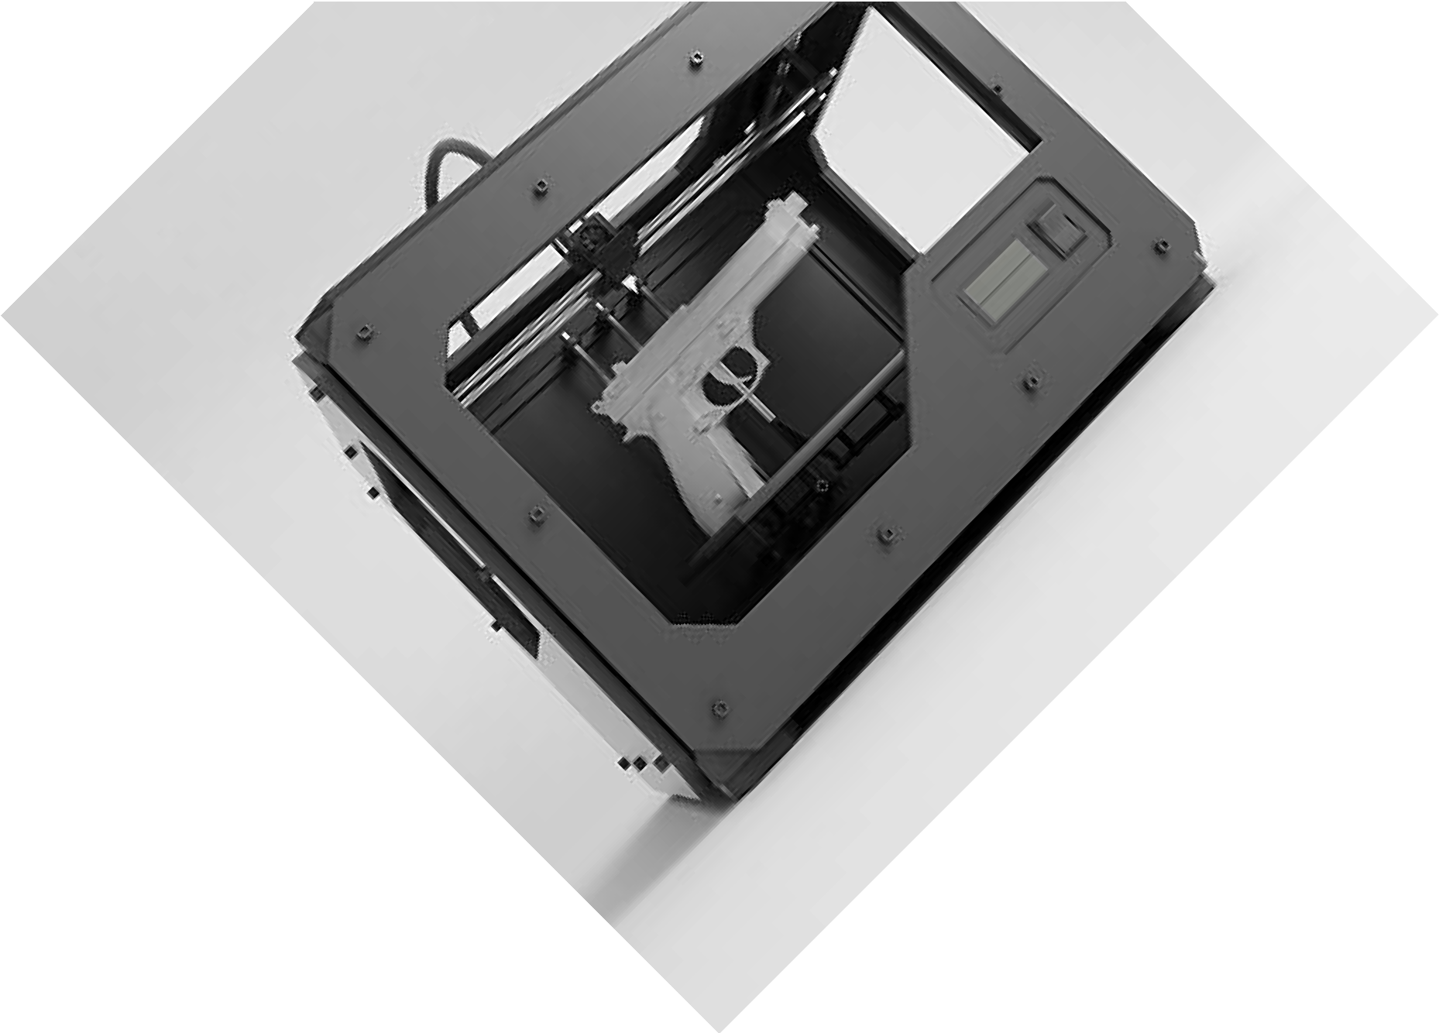


VISIL LabS
For Innovations
CONTACT US

CONTACT US
250/15, Periyar Pathai, Choolaimedu, Chennai, Tamil Nadu 600094
+91 89397 09676
connect@visiltech.com

SCAN TO KNOW MORE

www.visiltech.com

